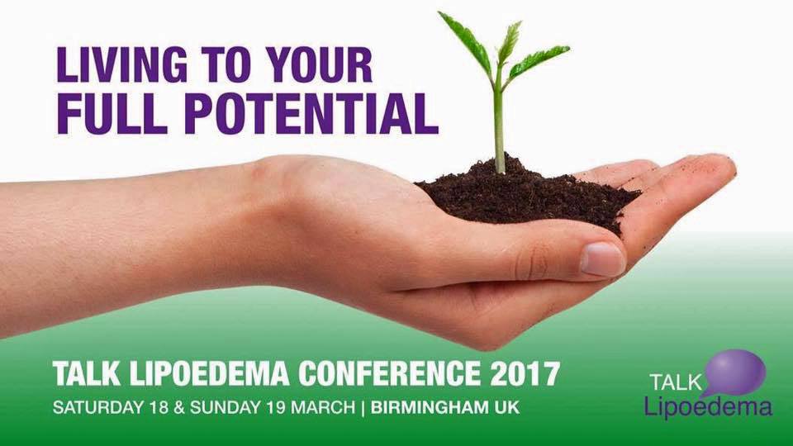

Exhibitor Review from Younique’s Kirsten
http://www.cosmeticsbykoko.com

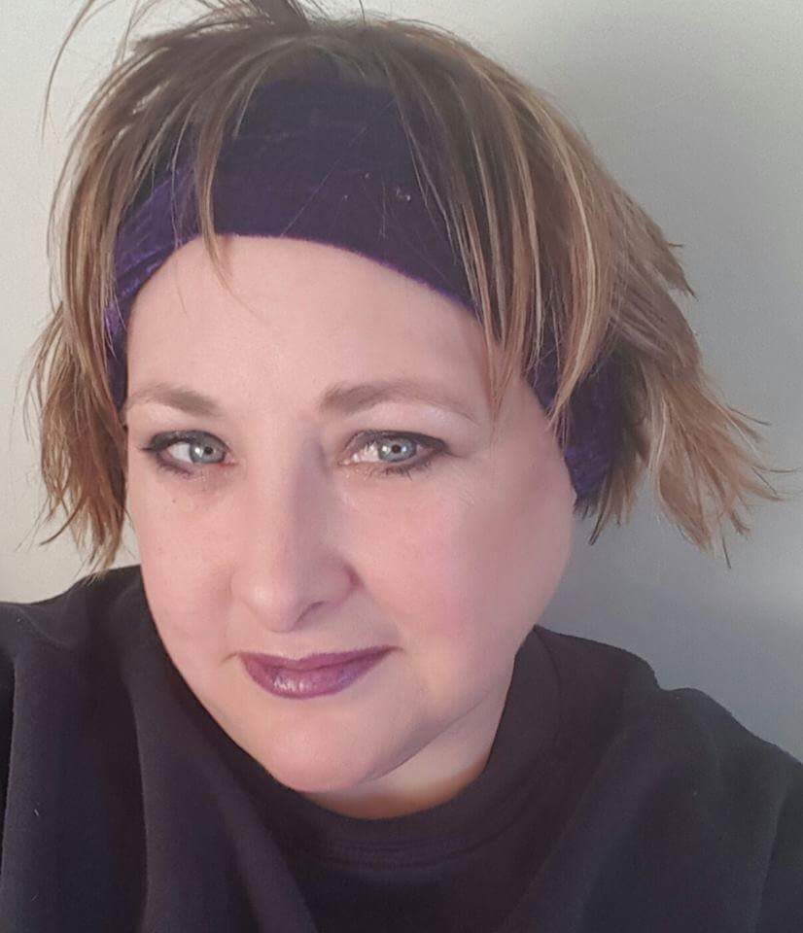
“As someone who has Lipoedema I understand how debilitating the disorder is both physically and, for many woman, to a greater effect, emotionally.

It’s the feeling of not being able to control how it makes you look and feel I believe is one of the biggest effects it has on your life.

I started my own company 18 months ago, by becoming a Presenter and selling Younique Cosmetics. It has been a wonderful way for me personally, to focus my energies on and stop obsessing about my body image. Younique’s ethos is to Uplift, Validate and Empower woman and so it wasn’t just the quality of the products that attracted me to the company but their belief system that all woman deserve to be free of feeling undervalued for whatever reason.

At our Lipoedema conference in March, I had the opportunity of having a Younique stall and giving the ladies a chance to experiment with the makeup, learning new techniques and skills, but more importantly just have a play with the cosmetics without feeling uncomfortable in their skin.

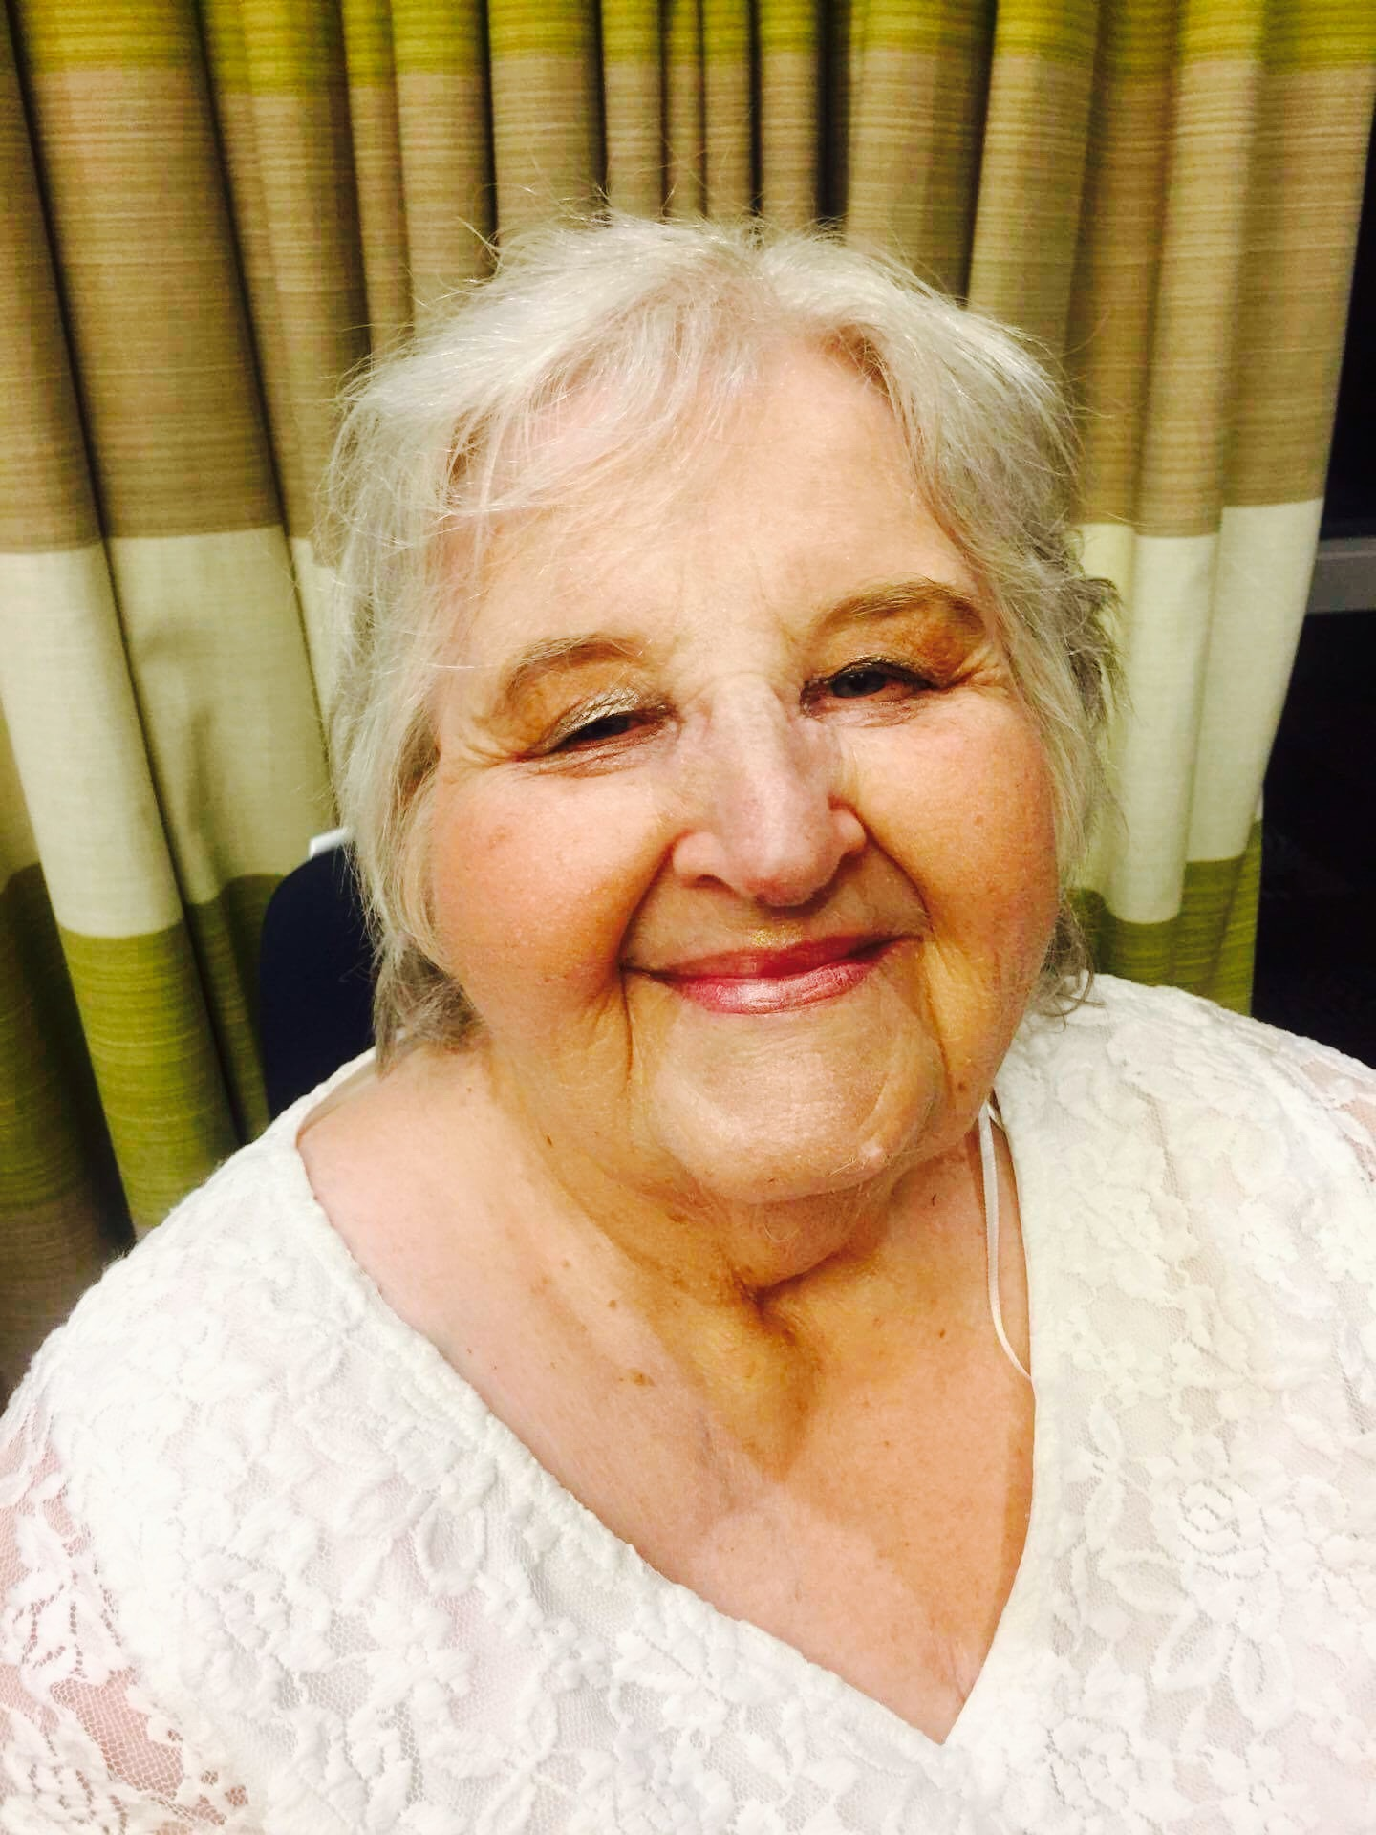

I was also responsible for doing the makeup for 9 gorgeous, courageous women who were super models (in the true sense of the word) at the fashion show on the Saturday night.
It was truly an honour to be part of such a wonderful event and spend time with “my people”.

